TELECOM CUSTOMER CHURN PREDICTION

Capstone Project Report - GROUP KILO

EXECUTIVE SUMMARY
This project successfully developed a machine learning model to predict customer churn in the telecom industry. Using a dataset of 7,043 customers, we achieved an accuracy of 82.19% using a Logistic Regression model.
Key Results:
- Best Model: Logistic Regression
- Accuracy: 82.19%
- Precision: 68.71%
- Recall: 60.05%
- F1-Score: 0.6409

1. INTRODUCTION
Customer churn is a critical business problem in the telecom industry. This project aims to identify which customers are likely to cancel their services and understand the key factors driving churn decisions.

2. DATASET OVERVIEW
Dataset: Telecom Customer Churn (IBM/Kaggle)
Total Records: 7,043 customers
Total Features: 31
Churn Rate: 26.54% (1,869 customers churned, 5,174 stayed)

3. METHODOLOGY
Data Preprocessing: Cleaned data, removed unnecessary columns, converted text to numbers
Data Split: 80% training (5,634 customers), 20% testing (1,409 customers)
Models Built: Logistic Regression and Random Forest

4. RESULTS & MODEL PERFORMANCE
Logistic Regression achieved 82.19% accuracy, outperforming Random Forest (79.49%)
Figure 1: Model Performance Comparison
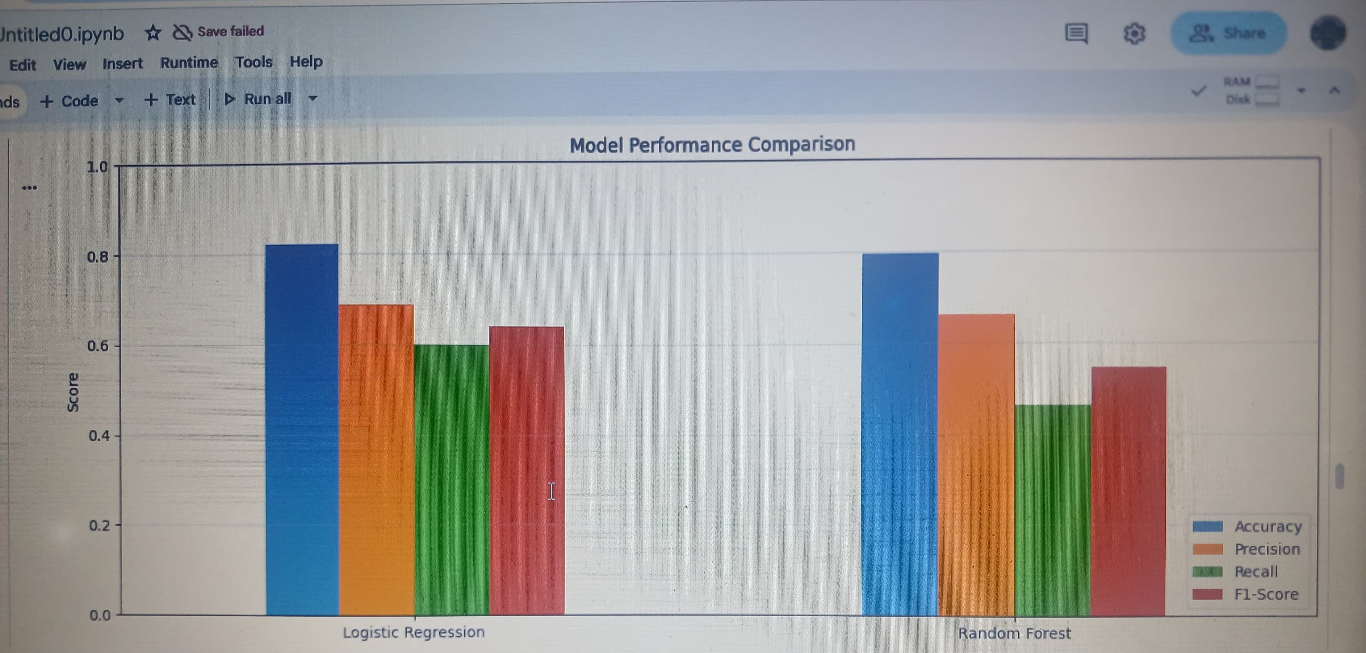

5. FEATURE IMPORTANCE ANALYSIS
Top 10 Most Important Factors:
- 1. Total Charges (19.53%) - New customers more likely to churn
- 2. Tenure (17.03%) - Longer tenure = lower churn
- 3. Monthly Charges (16.86%) - Higher fees = higher churn risk
- 4. Internet Service Type (3.73%)
- 5. Payment Method (3.73%)
Figure 2: Feature Importance Chart
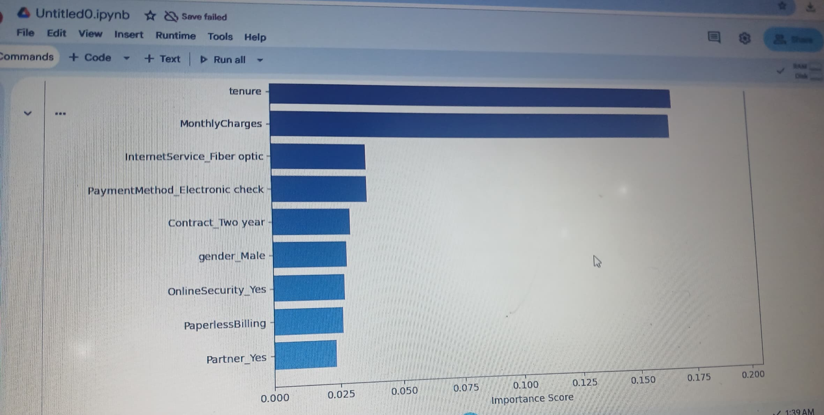

6. CONFUSION MATRICES
The confusion matrices show where the model made correct and incorrect predictions.
Figure 3: Confusion Matrices - Logistic Regression vs Random Forest
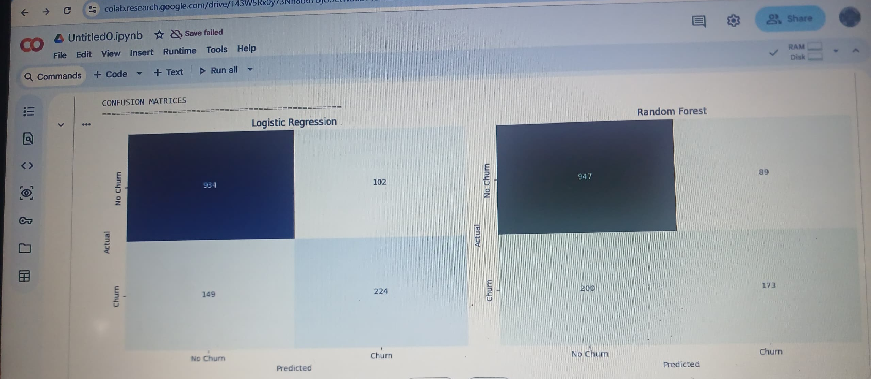

7. KEY FINDINGS
Customers Most Likely to Churn:
- - Low total lifetime charges (brand new customers)
- - Short tenure with company
- - High monthly charges (price sensitive)
- - Using fiber optic or electronic check payment

8. RECOMMENDATIONS
For Customer Retention:
- - Implement onboarding programs for new customers
- - Offer loyalty discounts for longer contracts
- - Use model to identify and contact high-risk customers monthly
- - Convert month-to-month customers to annual contracts
For Model Deployment:
- - Retrain monthly with new data
- - Monitor accuracy (alert if drops below 80%)
- - Integrate with customer database

9. CONCLUSION
This project successfully built a machine learning model with 82.19% accuracy to predict telecom customer churn. The model identified key factors driving churn and is ready for business deployment.
Key Takeaways:
- Model achieves 82.19% accuracy
- Identified top 10 churn factors
- 60.05% of actual churners caught by model
- 68.71% precision (minimal wasted retention efforts)
- Ready for immediate deployment

APPENDIX
Technologies: Python, pandas, scikit-learn, matplotlib, Google Colab
Dataset Source: IBM Telecom Customer Churn (Kaggle)
Models: Logistic Regression (1000 iterations), Random Forest (100 trees)

